**HACER CONSULTA**

Visualizar el contenido de una tabla creada

1. Visualizar todo el contenido de la tabla Orders Cláusula (SELECT)

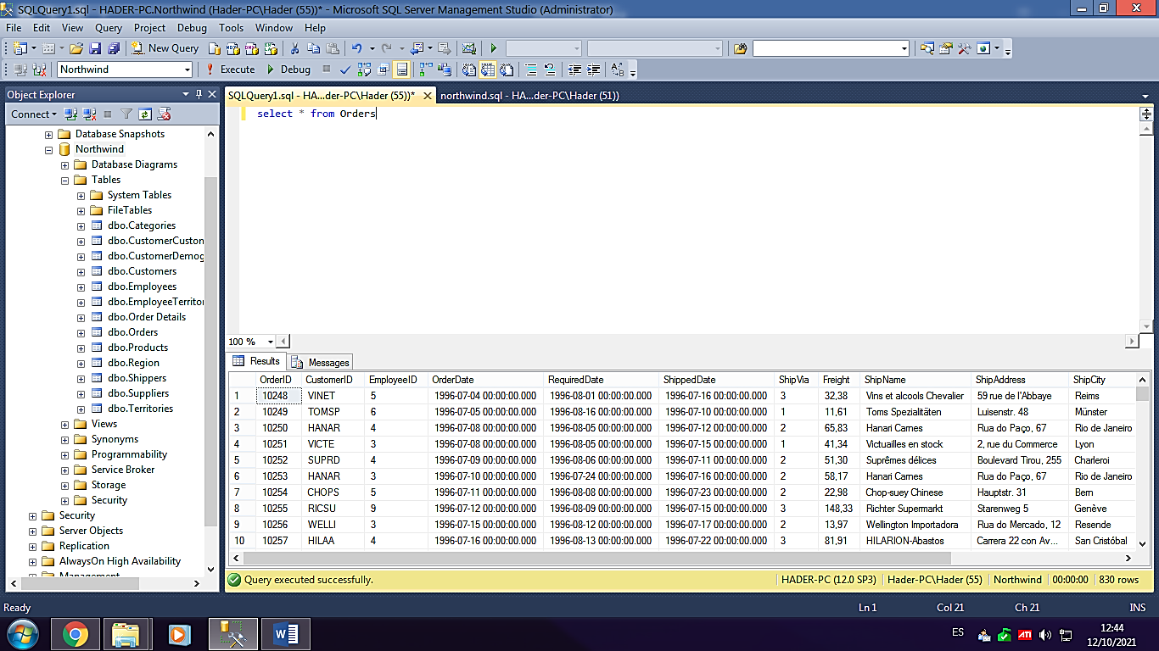-select * from Orders

-select OrderID, CustomerID, ShipCity from Orders

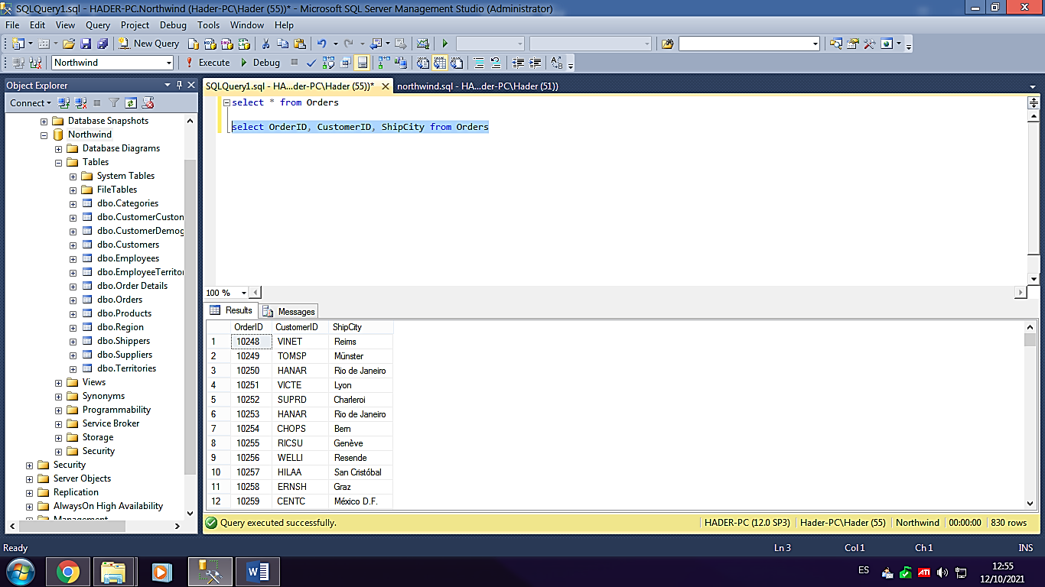

select * from Customers

-select * from Customers

-where CompanyName like 'B%'

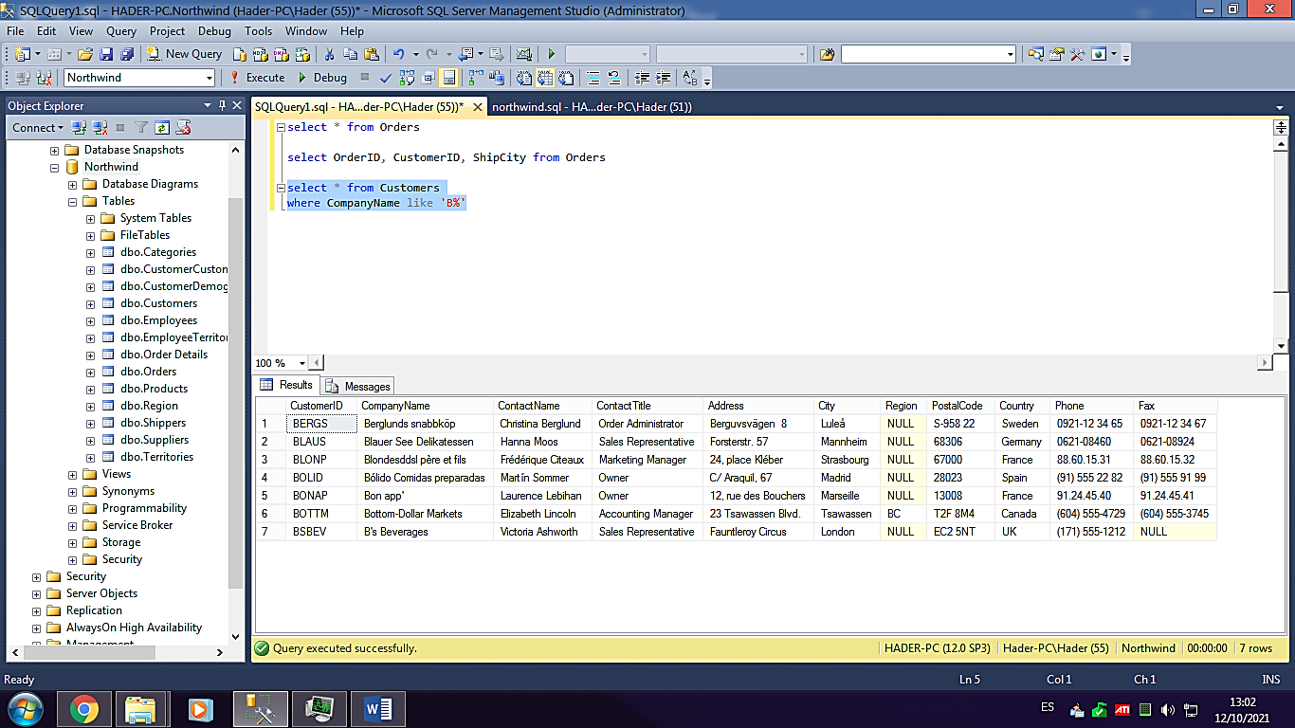

select * from Customers

where CustomerID like 'blaus'

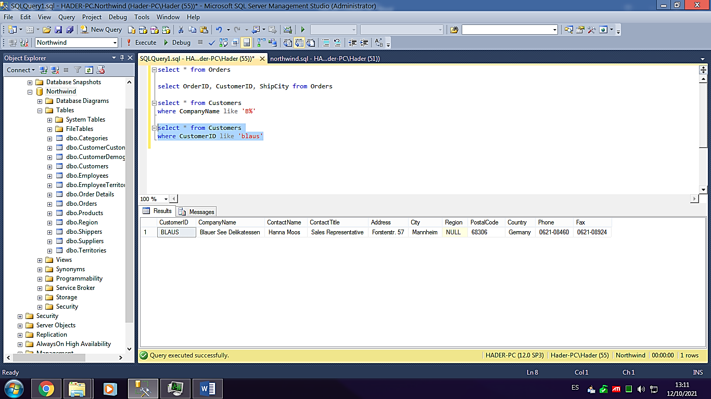

select * from Customers

where CompanyName like 'B%'

order by ContactName

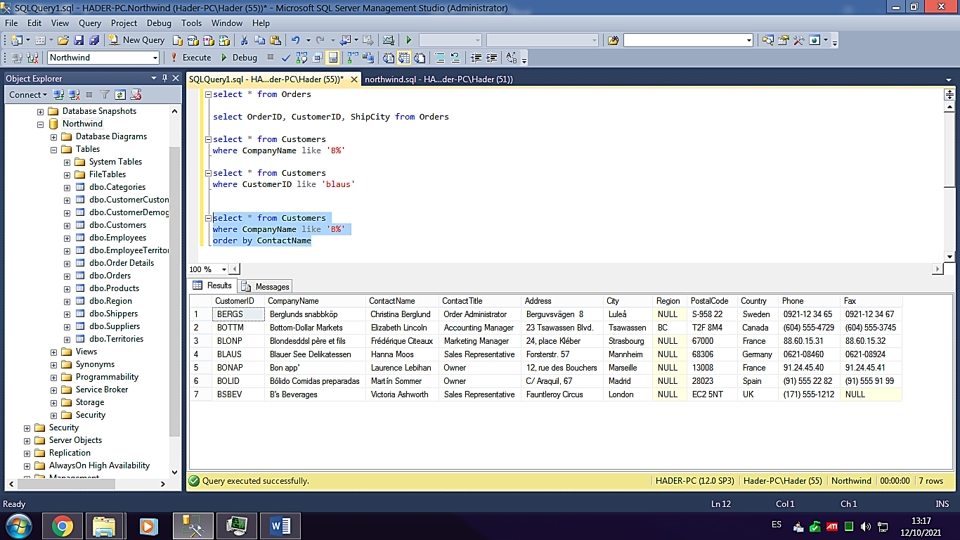

select * from Customers

where CompanyName like 'B%'

order by ContactName desc

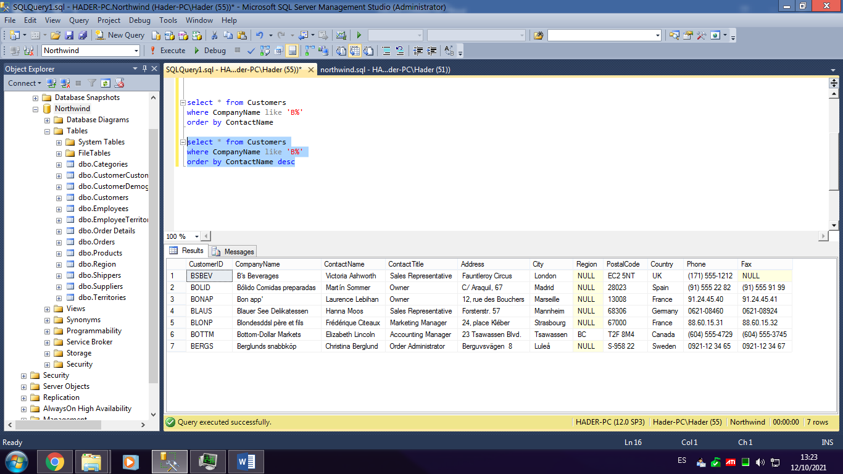

select * from Products

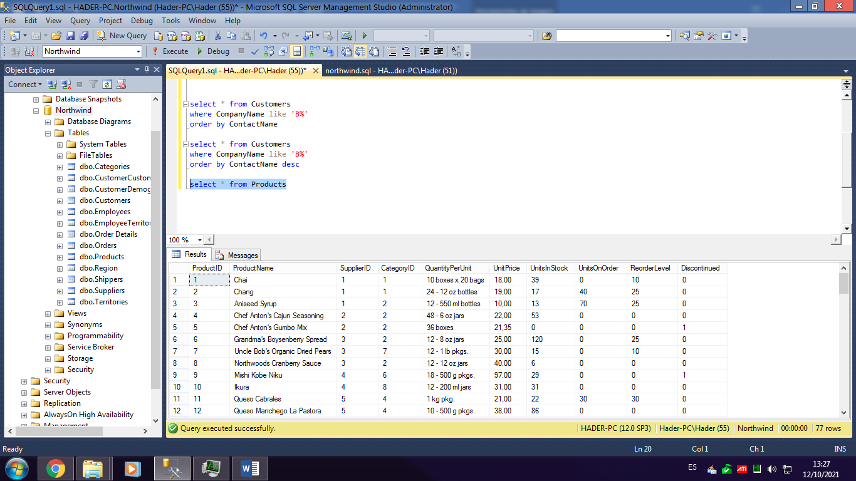

select * from Products

select SupplierID, COUNT (SupplierID) as Cantidad

from Products

group by SupplierID

